Zohaib Siddique

Roll No 233517

BSCS A

**Lab Task 12**

**MOBILE COMPUTING LAB**

**Add Note Screen:**

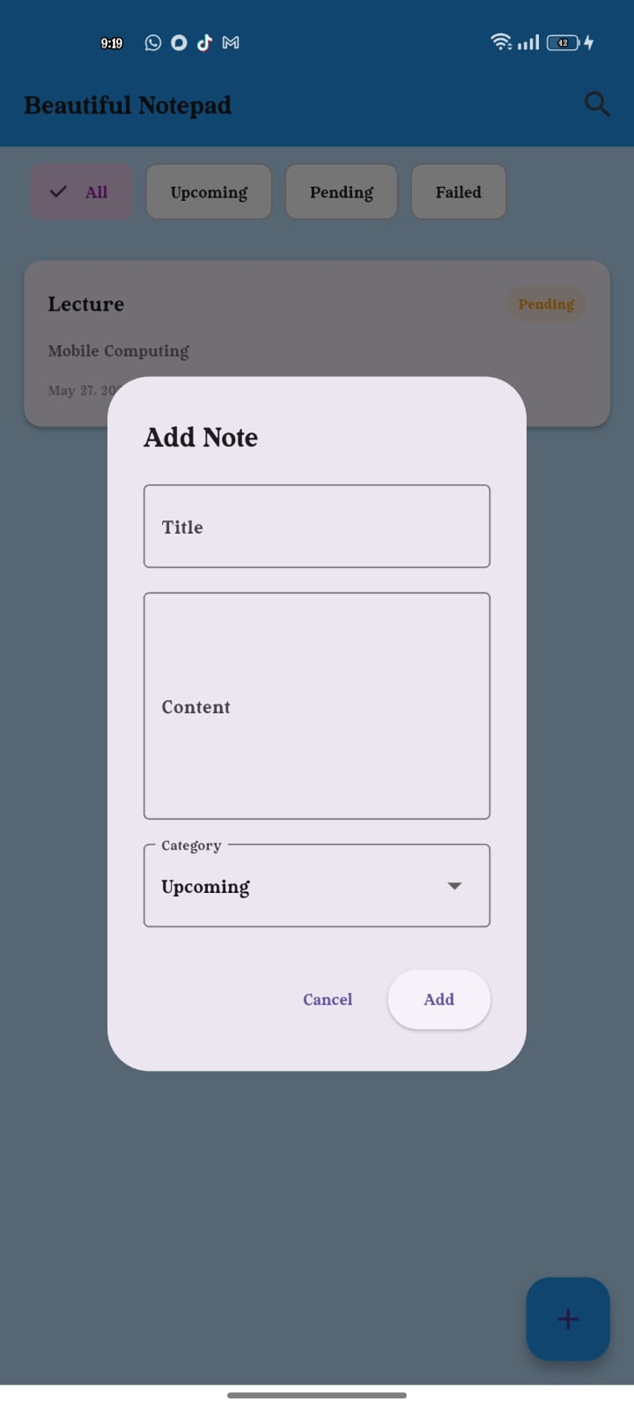

**Home Screen:**

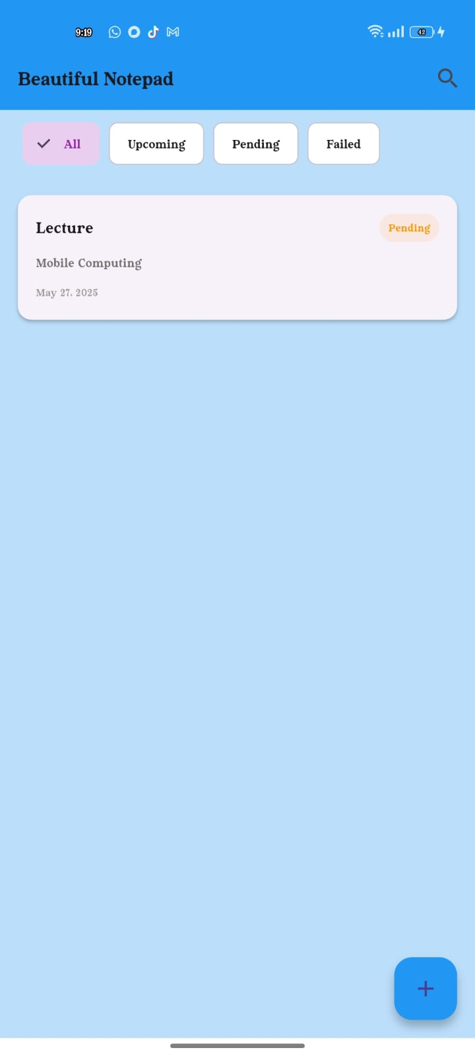

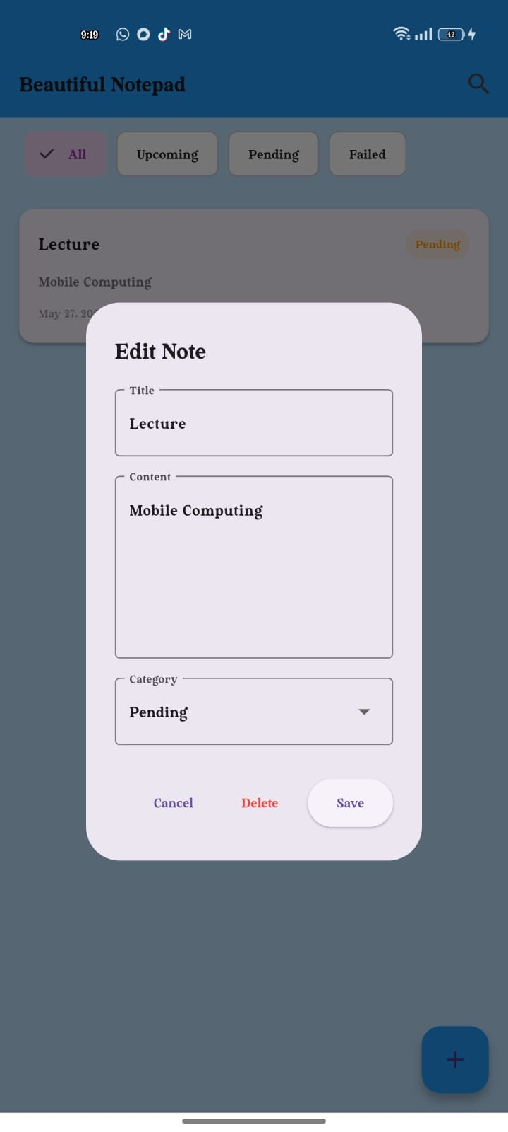**Edit Screen/Delete Screen:**

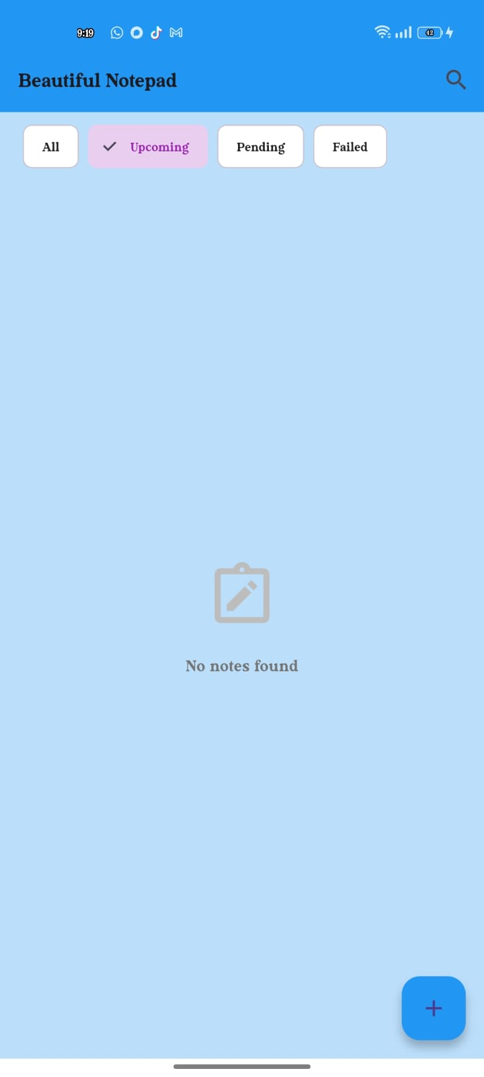**Upcoming Notes Screen:**

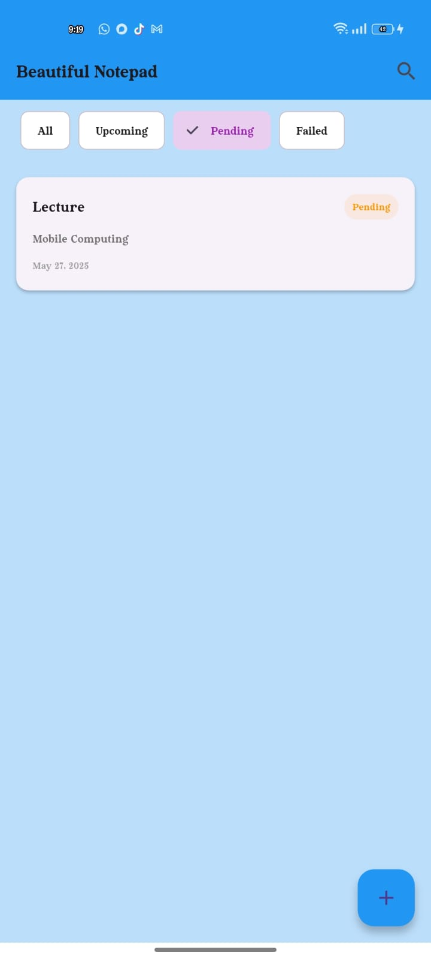**Pending Screen:**